This is a website about the Environmental protection club, and it defines as five web pages.

All five web pages have a menu on the top and a footer at the end.

The mean is defined in four-part, which are **Home**, **Earth's Ecological Environment**, **About Us**, and **Join Us**. In **Earth's Ecological Environment** mean, it has two sub means which are **Forest Ecological Conservation** and **Marine Ecological Conservation**. On the right have a search button.



In the footer, it shows the information about the creator.



On the home page, the goals of the club are described, and there are two boxes explaining Why need to promote environmental protection? and How to promote environmental protection? Also, have a gif about Environmental protection.

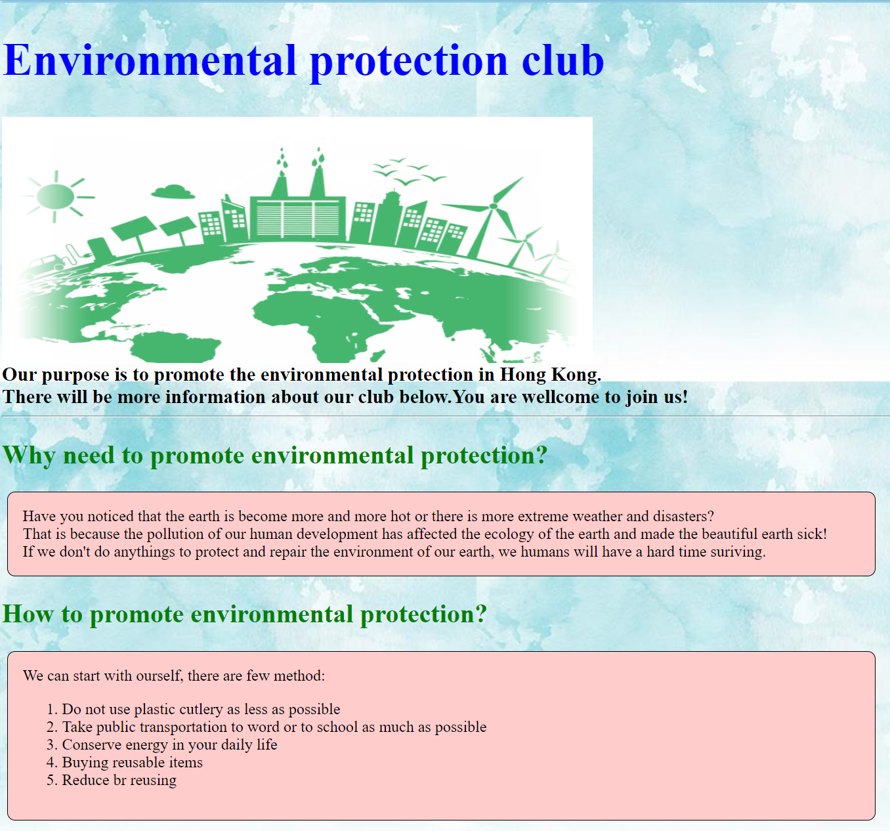

The Join Us page has a form to correct member details, which are name, phone number, gender, email, home address, and member’s birthday.

If the user enters the wrong format it will have an error message to tell the user to enter the correct format.

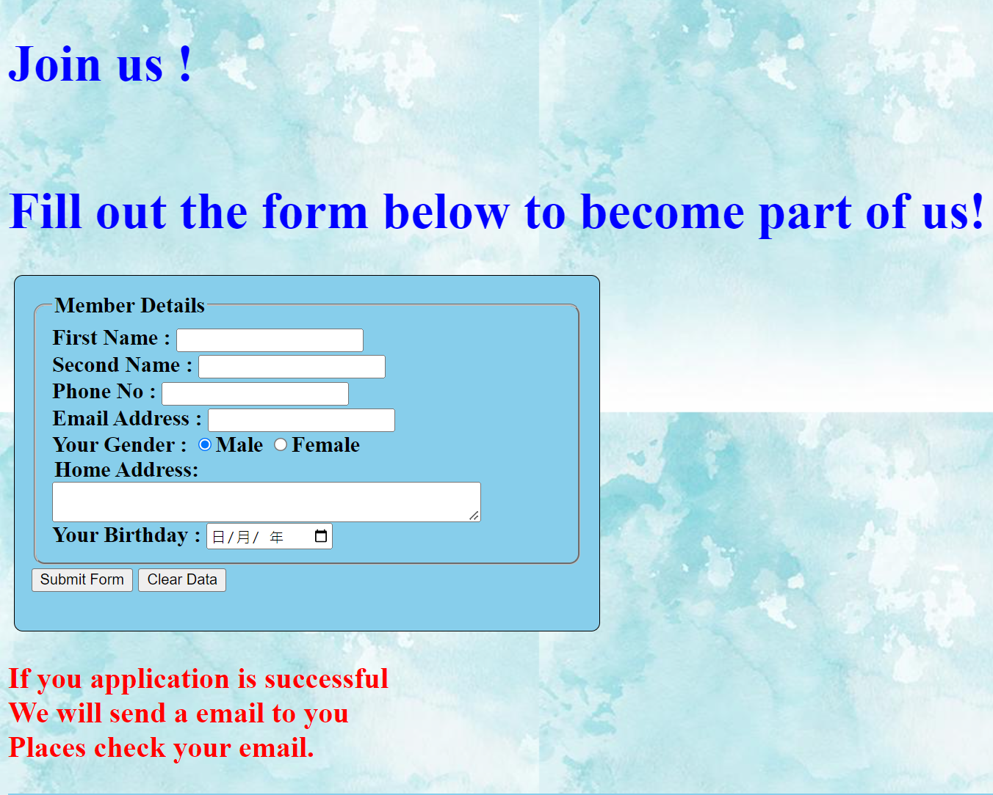

The About Us page has detail about the club meeting and has three boxes including the club activities.

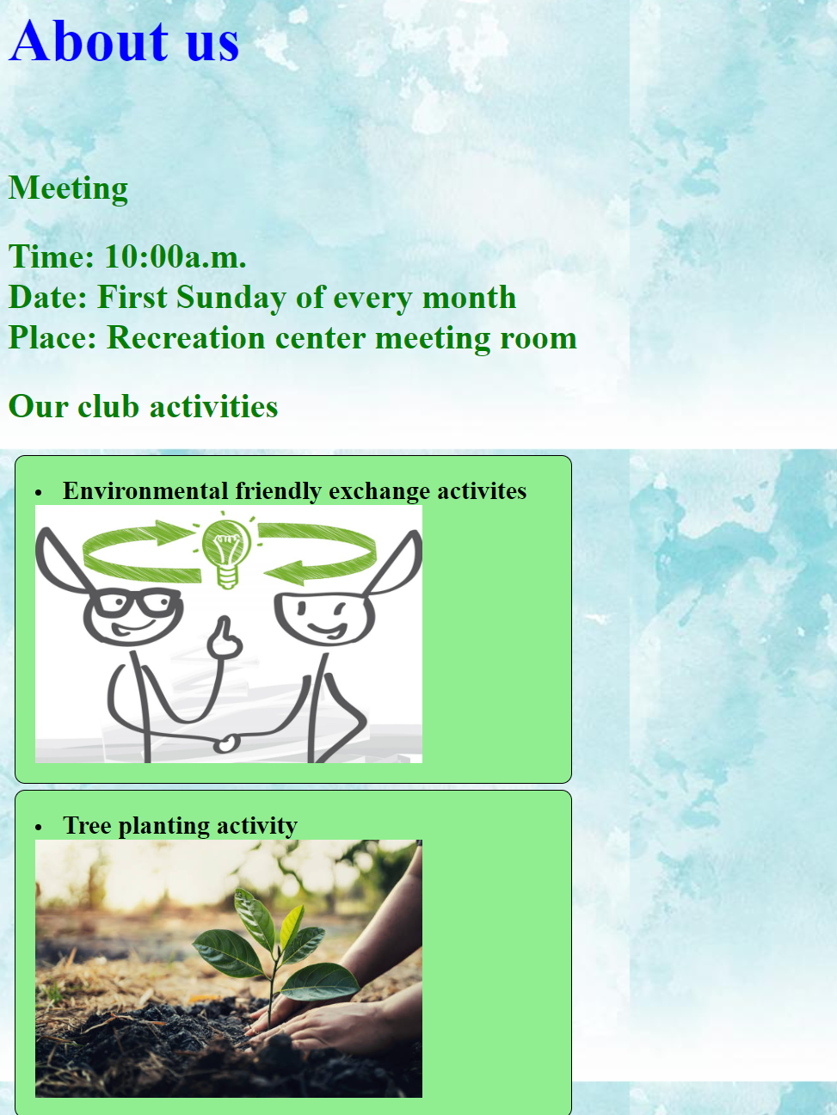

On Earth's Ecological Environment has two sub means both two are the same format.

First is the introduction of Forest Ecological Conservation and Marine Ecological Conservation and then there will be some methods that can help to protect the Earth's Ecological Environment.

